Architecture Modernism at its Peak
Name:
Institution Affiliate:
Course:
Date:

Introduction
The contemporary architecture has marked a milestone in the global history especially in the latest structures. The architects are doing their best to improve the architecture through the use of modern technology especially in the evolving world. The international modernism aims on various issues like emphasizing on the architectural volume over the mass, prohibiting the symmetry of traditional architecture. The contemporary architectural designs and building process has made use of the most efficient materials like glass, concrete and steel. The paper will research on, modern styles of architecture in constructions and popular types of modernism in the architecture including modern, brutalist, postmodern, corporate and new formalism modernisms.
Structural innovations
The structural innovations were initiated by the development of the steel frame which became the most vital aspect in the establishment of the contemporary architecture where the iron frames were substituted with steel. The use of steel as the roots of the houses led to the construction of tall buildings in places like Chicago and the materials of making the walls of these structures kept the weather out and gave the structure its architectural shape. The tall buildings were constructed with thick walls and strong base which held and support the weight above them (Ahuja, 2000).
The popular modernism
When modernism was initiated, it came with various forms and the roles of architecture which were essential in the society. The favorite innovation in the architecture started in the 1950's, and sometimes it is referred to as "space age." The buildings which were constructed under the popular modernism had the billboards to advertise themselves.
The buildings have featured elements which are like the folded plates, and the vault of roofs have concrete shell barrels. The architectures designed the buildings with jutting cantilevers and amoebic curves which comprises the bright colors and sometimes these buildings had graphics which were striking. Neon signs were added to these structures which helped to identify a particular building with ease. One of the significant examples of these popular modernism includes Perth's dry cleaners located in Manitoba (Brown, 2000).
The building was designed with the unusual roof lines which were folded like plates, and the windows were made of glass which elevated to the same height as walls. The roof was designed by the architects to be eye-catching with an intention to draw attention. The cathedrals of various churches are also one of the modern famous modernism structures which have marked a milestone in the history of famous architectural structures around the globe.
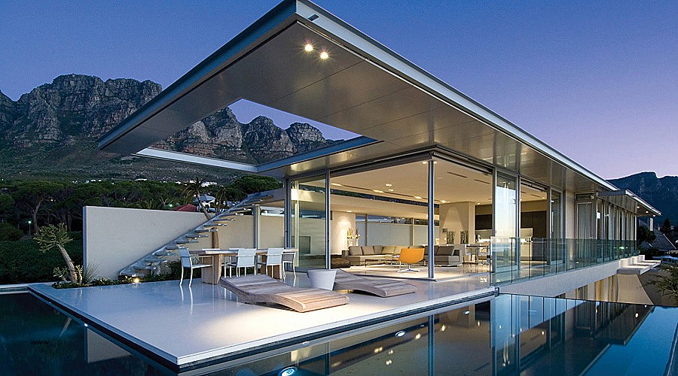
Brutalist Modernism
The style of brutalist emphasizes the use of materials and textures which yields in the production of very high expressive structures. The method has an uncompressing approach in the displaying of the services and arrangements which are albeit in the steel building instead of reinforcement of the concrete. In the contemporary brutalist modernism, the architects are using Belton but as the raw concrete in the making of patterns by the wooden shuttering which are later replicated via board marking. For instance, the work of Lasdun where the aggregation is pick-hammered or bush as demonstrated by the architectural practice of Barbican Estate which is located in London.
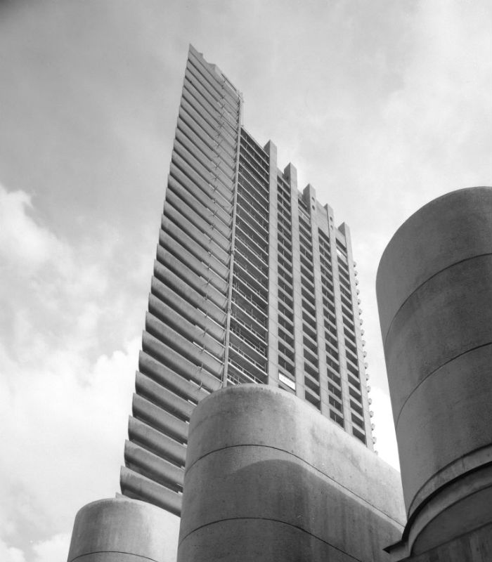
The construction of the brutalism structures the scale is most important because the style of the buildings is attributed to the massive concrete shapes which collide abruptly. The ventilation towers and service ducts are displayed in an open forum. In the contemporary brutalist buildings there are crucial features which define the structures, and they include the unusual shapes with rough non-finished surfaces. The buildings should have the heavy materials and comprise large forms. The windows of these architectural structures should have small windows as compared to the other parts (Banham, 2011).
Corporate modernism
In 1950's the demand for the corporate buildings was rising, and the features of these structures included the eye-catching buildings where the forms were to be less cerebral, and the houses had to be more outstanding as compared to the other global structures. The corporate modernism consists of the specific type of the universal design of building where large corporations invest and showcase the future products by the contemporary innovations in the modern technological architecture. The corporate structures are made of steel frameworks, and consist the modernist vocabulary of the ribbon windows and are designed using simple geometric forms.
These structures are to be executed using a specific architectural design with strict formal standards. Some of the iconic buildings that been hailed as the highest achievements in the modern corporate architecture include the OEBB headquarters in Australia. The structure is curved form and is the headquarters of the railway's company departments which is an example of the contemporary corporate modernism which is 288 feet tall marking a vital landmark in the country.

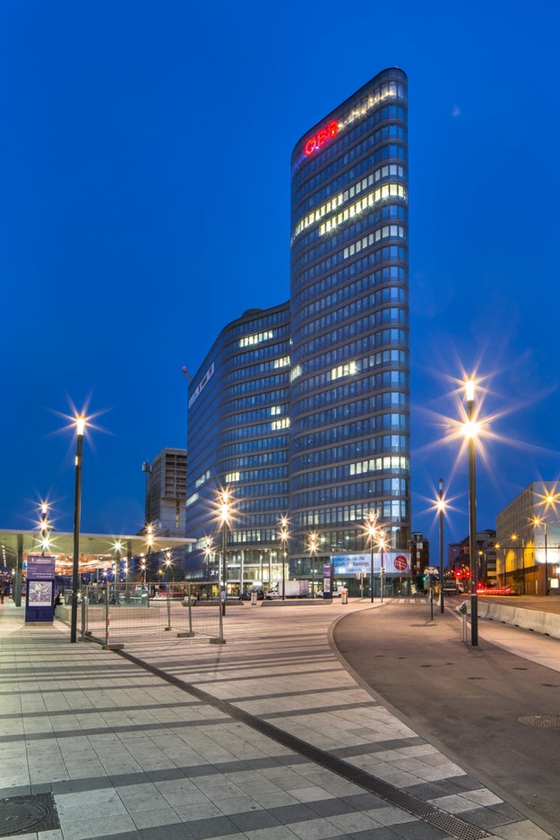
New Formalism
The new formalism type of architecture emerged in the 1960’s and this style involved both adaptations of the traditional techniques with the use of contemporary technology and the most popular features. The architectures designing the new formalism buildings had to embrace various classical precedents like the proportions of the structures and the scales. The columns have to be traditional and highly stylized with the use of mezzanine as the compositional device. The concrete used in the designing of the new formalism designs are like the umbrella shells, folded plates, and waffle slabs.

The structures which are built using the new formalism technique should have a well-organized hierarchy of the space, and a lot of emphases is placed in the construction grid or structure. The building of a single volume is preferred in the making of these structures, and they are often separated from nature by setting them upon an elevated base or podium. Multiple buildings which are designed using this style have the exotic flavor, and the exterior wall surfaces are made up of the cast stones. The marbles and bricks are also used in the construction of these structures which are designed on a larger urban scales using the grand symmetry and axis to attain the monumentally of the building. The new formalism buildings comprise of many windows which are either rounded or pointed. Most of the buildings which are designed with this style include the banks, civic buildings and small offices (Brown, 2000).
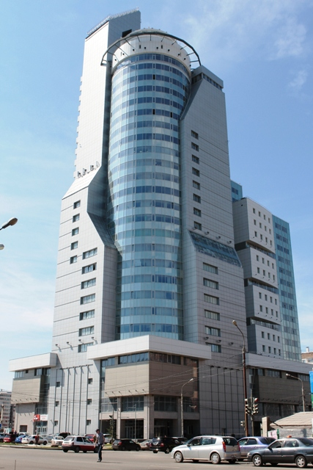
Postmodernism
The postmodernism first appeared on the landscape of the architectures around the mid-1960's which was a result of rejecting high modernisms functions. The postmodernisms had bright colors, and the structures had unusual shapes. In this type of design, the building is divided into various segments according to the functions intended to be performed inside the building. Majority of these contemporary structures have features which are borrowed from previous styles and also asymmetry, curved forms, and bright colors. Most of these buildings represent monuments which are designed with the use of the advanced contemporary technology.
One of the features which make the postmodernism structures to be outstanding is the presence of the oblique forms and the asymmetrical styles. Some of these architectural works have sloping floors and leaning walls. These structures are rarely symmetrically balanced and may lack order, with the tilting oblique features which may seem like they can fall off. Color is an essential aspect of the designing of these buildings, and in some cases, the colored glasses are used.
Most of these structures have features which have humor, especially in the United States. Some of the sculptures are used in the construction of these buildings. The essence of including these features in the postmodern architecture work is to communicate various meanings which are ambiguous and as the unification of multiple architects who did not work together in making these structural advancements. Most of these buildings are located in New York City and various streets of England (Jencks, 2011).
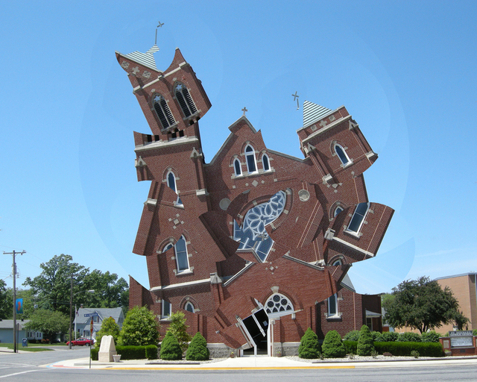
Conclusion
The paper has studied on various architecture modernism at its peak by focusing on the aspect of the structural innovations. The studied typed of architectural modernisms include corporate, brutalism, popular, new formalism and postmodernism. The article has evaluated various forms of modernism in the field of architecture and providing multiple examples which have marked a hallmark in the history of the world. The paper has also explained various features of each type of modernism which make these structures to be outstanding. Therefore, the contemporary architectural structures in the world have improved using the advanced technology and usage of high-quality materials.

References
Ahuja, G. (2000). Collaboration Networks, Structural Holes, and Innovation: A Longitudinal Study. Administrative Science Quarterly, 45(3), 425. Doi: 10.2307/2667105
Lara, F. L. (2008). The Rise of Popular Modernist Architecture in Brazil. doi:10.5744/Florida/9780813032894.001.0001
Banham, R. (2011). The New Brutalism. October, 136, 19-28. Doi: 10.1162/octo_a_00034
Brown, D. (2000). Words and Buildings: 2000299Adrian Forty. Words and Buildings: A Vocabulary of Modern Architecture. London: Thames and Hudson 2000. 335 pp, ISBN: 0 500 34172 9 £28.00. Reference Reviews, 14(6), 33-34. doi:10.1108/rr.2000.14.6.33.299
Jencks FAT, C. (2011). What is Radical Post-Modernism? / Post-Modernism: An Incomplete Project. Architectural Design, 81(5), 14-23. doi:10.1002/ad.1291

